**Business cycle**

* The business cycle describes short-term fluctuations (expansions and contractions) of real GDP around the long-term trend.
* Contraction: from peak (highest) to trough (lowest)

Expansion: from trough to peak

* The business cycle can be expressed in terms of the growth rate or the level of GDP (eg. slower than average GDP growth & falling GDP level)
* The severity of business cycle fluctuations around the world has moderated since the 1990s. Because:

1. Central Bank independence
2. Inflation-targeting monetary policy
3. Trade openness and market liberalization (risk-sharing)
4. Structural transformations (manufacturing to services)

**Real GDP and other factors**

* When GDP growth slows, the unemployment rate tends to increase
* When GDP growth falls, inflation falls too. When it doesn’t it is called “stagflation”.

**Potential output, Actual output and Output gap**

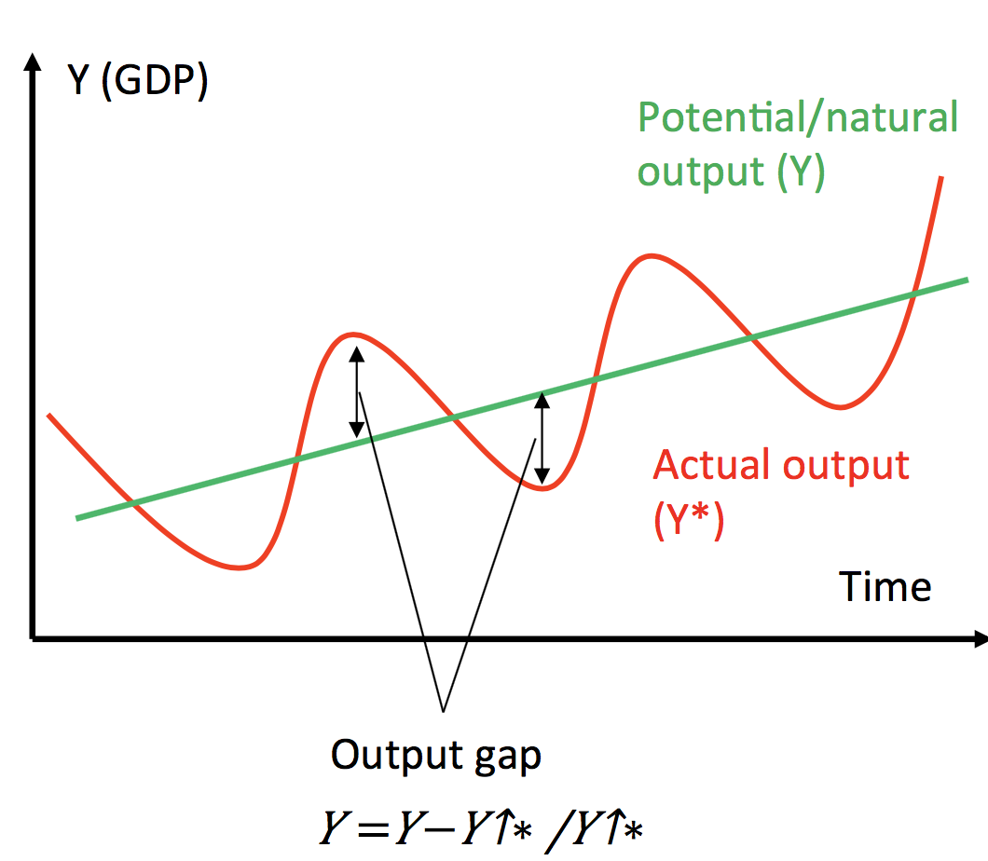

* During a recession, “actual output” is below “potential output”. The difference is called the “output gap”.
* Potential output / Natural Output / potential GDP / full employment output (y*) :
* The amount of output (real GDP) that an economy can produce when using its resources, such as capital and labour, at normal rates.
* It can grow over time with increases in the number of labour and capital resources available and increases in their productivity
* One reasons for economic fluctuations is changes in the level of potential output, signified by y*:  
  1) An extensive drought could cause a significant fall in potential output growth, leading to a contraction or recession.

2) A period of particularly repaid innovation could cause unusually large growth in potential output, leading to an expansion or boom.

* Varies less than actual output
* Depends on capital stock (number of machines etc.), real interest rates, population, skill, technology, natural resources
* Can jump up (new technology, discover oil) or fall (drought)
* Unemployment = natural level
* Output gaps:
* If economic fluctuations are unusual and require a policy response, some way to identify the size of the fluctuation is needed.
* Economic fluctuations arise when actual output does not always equal potential output:

1. When (y-y*) < 0: There is an underutilisation of resources; a contractionary gap.

--- recession --- rise in unemployment

1. When (y-y*) > 0: There is an overutilization of resources, an expansionary gap.

--- booms --- rise in inflation

* It measures how far actual output is from its normal level at a particular time.
* y* is potential output and y is actual output (real GDP), then the output gap is:

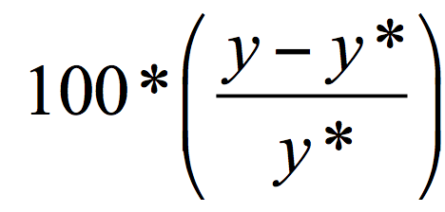

(When measured this way, the output gap is being expressed in terms of the percentage deviation of actual real GDP from potential real GDP)

* Actual output deviates from potential output, creating cyclical unemployment, because of “sticky prices”:

1. If aggregate demand falls because of:

--- less confidence about future growth/income (expectations)

--- A recession overseas

--- An asset bubble bursts, reducing wealth (eg.2008)

1. In the short run, prices stay the same, quantity falls:

--- Businesses respond to lower demand by selling less

--- Sticky prices and wages: It takes time for them to change menus/contracts

--- Higher unemployment: They tend to fire some people, before they lower wages for everyone (unemployment)

1. In the long run, prices also fall, quantity falls less:

--- Businesses eventually lower prices and wages

--- Lower prices and wages: quantity of output re-bounds

--- Lower (Involuntary) unemployment: lower wages

* Actual output:
* Can be below potential output (contraction/ unemployment) or above potential output (expansion/ overtime/ inflation). Both cause problems.
* Depends on nominal interest rates, aggregate demand, government spending.

**Okun’s law**

* 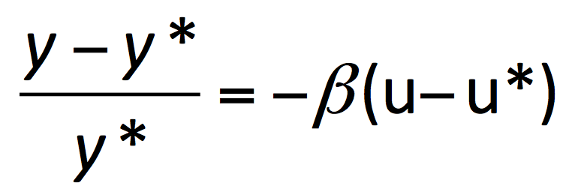

u*=natural unemployment rate, y*=potential output, y = real output, beta = coefficient rate

* It is also stated as the relationship between the unemployment rate and the output gap
* Each extra percentage point of cyclical unemployment is associated with approximately a 1.8 percentage point (for Australia) increase in the output gap measured in relation to potential output.
* If 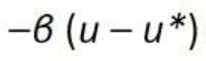is negative --- recessionary gap

**Short-term fluctuations**

* Reasons for changes in real GDP Growth:

1. Growth in potential output itself differs from normal.
2. Potential output is growing at the normal rate, but actual output is above or below potential output.

* Government can help to eliminate output gaps by influencing total spending.
* If demand continues to differ from potential output, firms will eventually adjust their prices to eliminate output gaps.
* Over the long run, changes in prices will bring the economy back to potential output.

**Fiscal Policy**

* Engineer: The government
* Lever: Taxes and spending
* Objective: Full employment
* Considerations: Balanced budget over the business cycle
* Channel: Aggregate government demand (CG + IG)
* Reaction speed: Slow

**Monetary Policy**

* Engineer: The central Bank (RBA)
* Lever: Nominal interest rates
* Objective: Stabilize inflation (neutralize sticky prices)
* Considerations: Asset price bubbles
* Channel: Aggregate private demand (C+I)
* Reaction speed: Fast

Q:

3.1 How can the perfectly competitive model be used to understand trends in the labour market?

3.2 What have been the five major trends in the labour market in the post-war era?

3.3 What factors influence firms’ demand for labour?

3.4 What factors influence workers’ supply of labour?

3.5 What are the three different types of unemployment?

3.6 For what reasons do some countries find it difficult to achieve full employment?